# Brainstorm & Idea Prioritization Template

Date: 12 June 2025

Team ID:LTVIP2025TMID43376

Project Name: PatternSense: Classifying Fabrics Using Deep Learning

Maximum Marks: 4 Marks

## Step 1: Team Gathering, Collaboration and Select the Problem Statement

Problem Statement:  
The manual classification of fabric patterns in the textile industry is time-consuming and prone to human error. Our goal is to develop a deep learning-based system capable of recognizing and classifying various fabric patterns automatically and accurately, streamlining the quality control and sorting process.

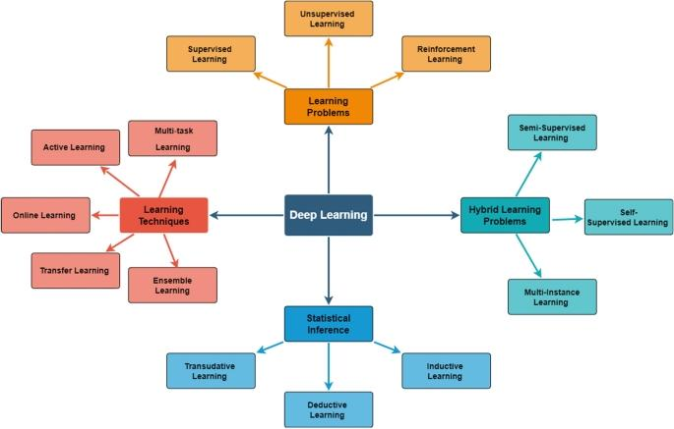

## Step 2: Brainstorm, Idea Listing and Grouping

Raw Ideas:

* - Use Convolutional Neural Networks (CNNs) for pattern recognition.
* - Create a dataset of high-resolution fabric images with labeled patterns.
* - Implement a mobile app for real-time pattern classification.
* - Integrate with textile production systems for automated quality checks.
* - Use data augmentation to improve model generalization.
* - Add support for multiple fabric types and weave styles.
* - Develop a visual dashboard for pattern classification reports.

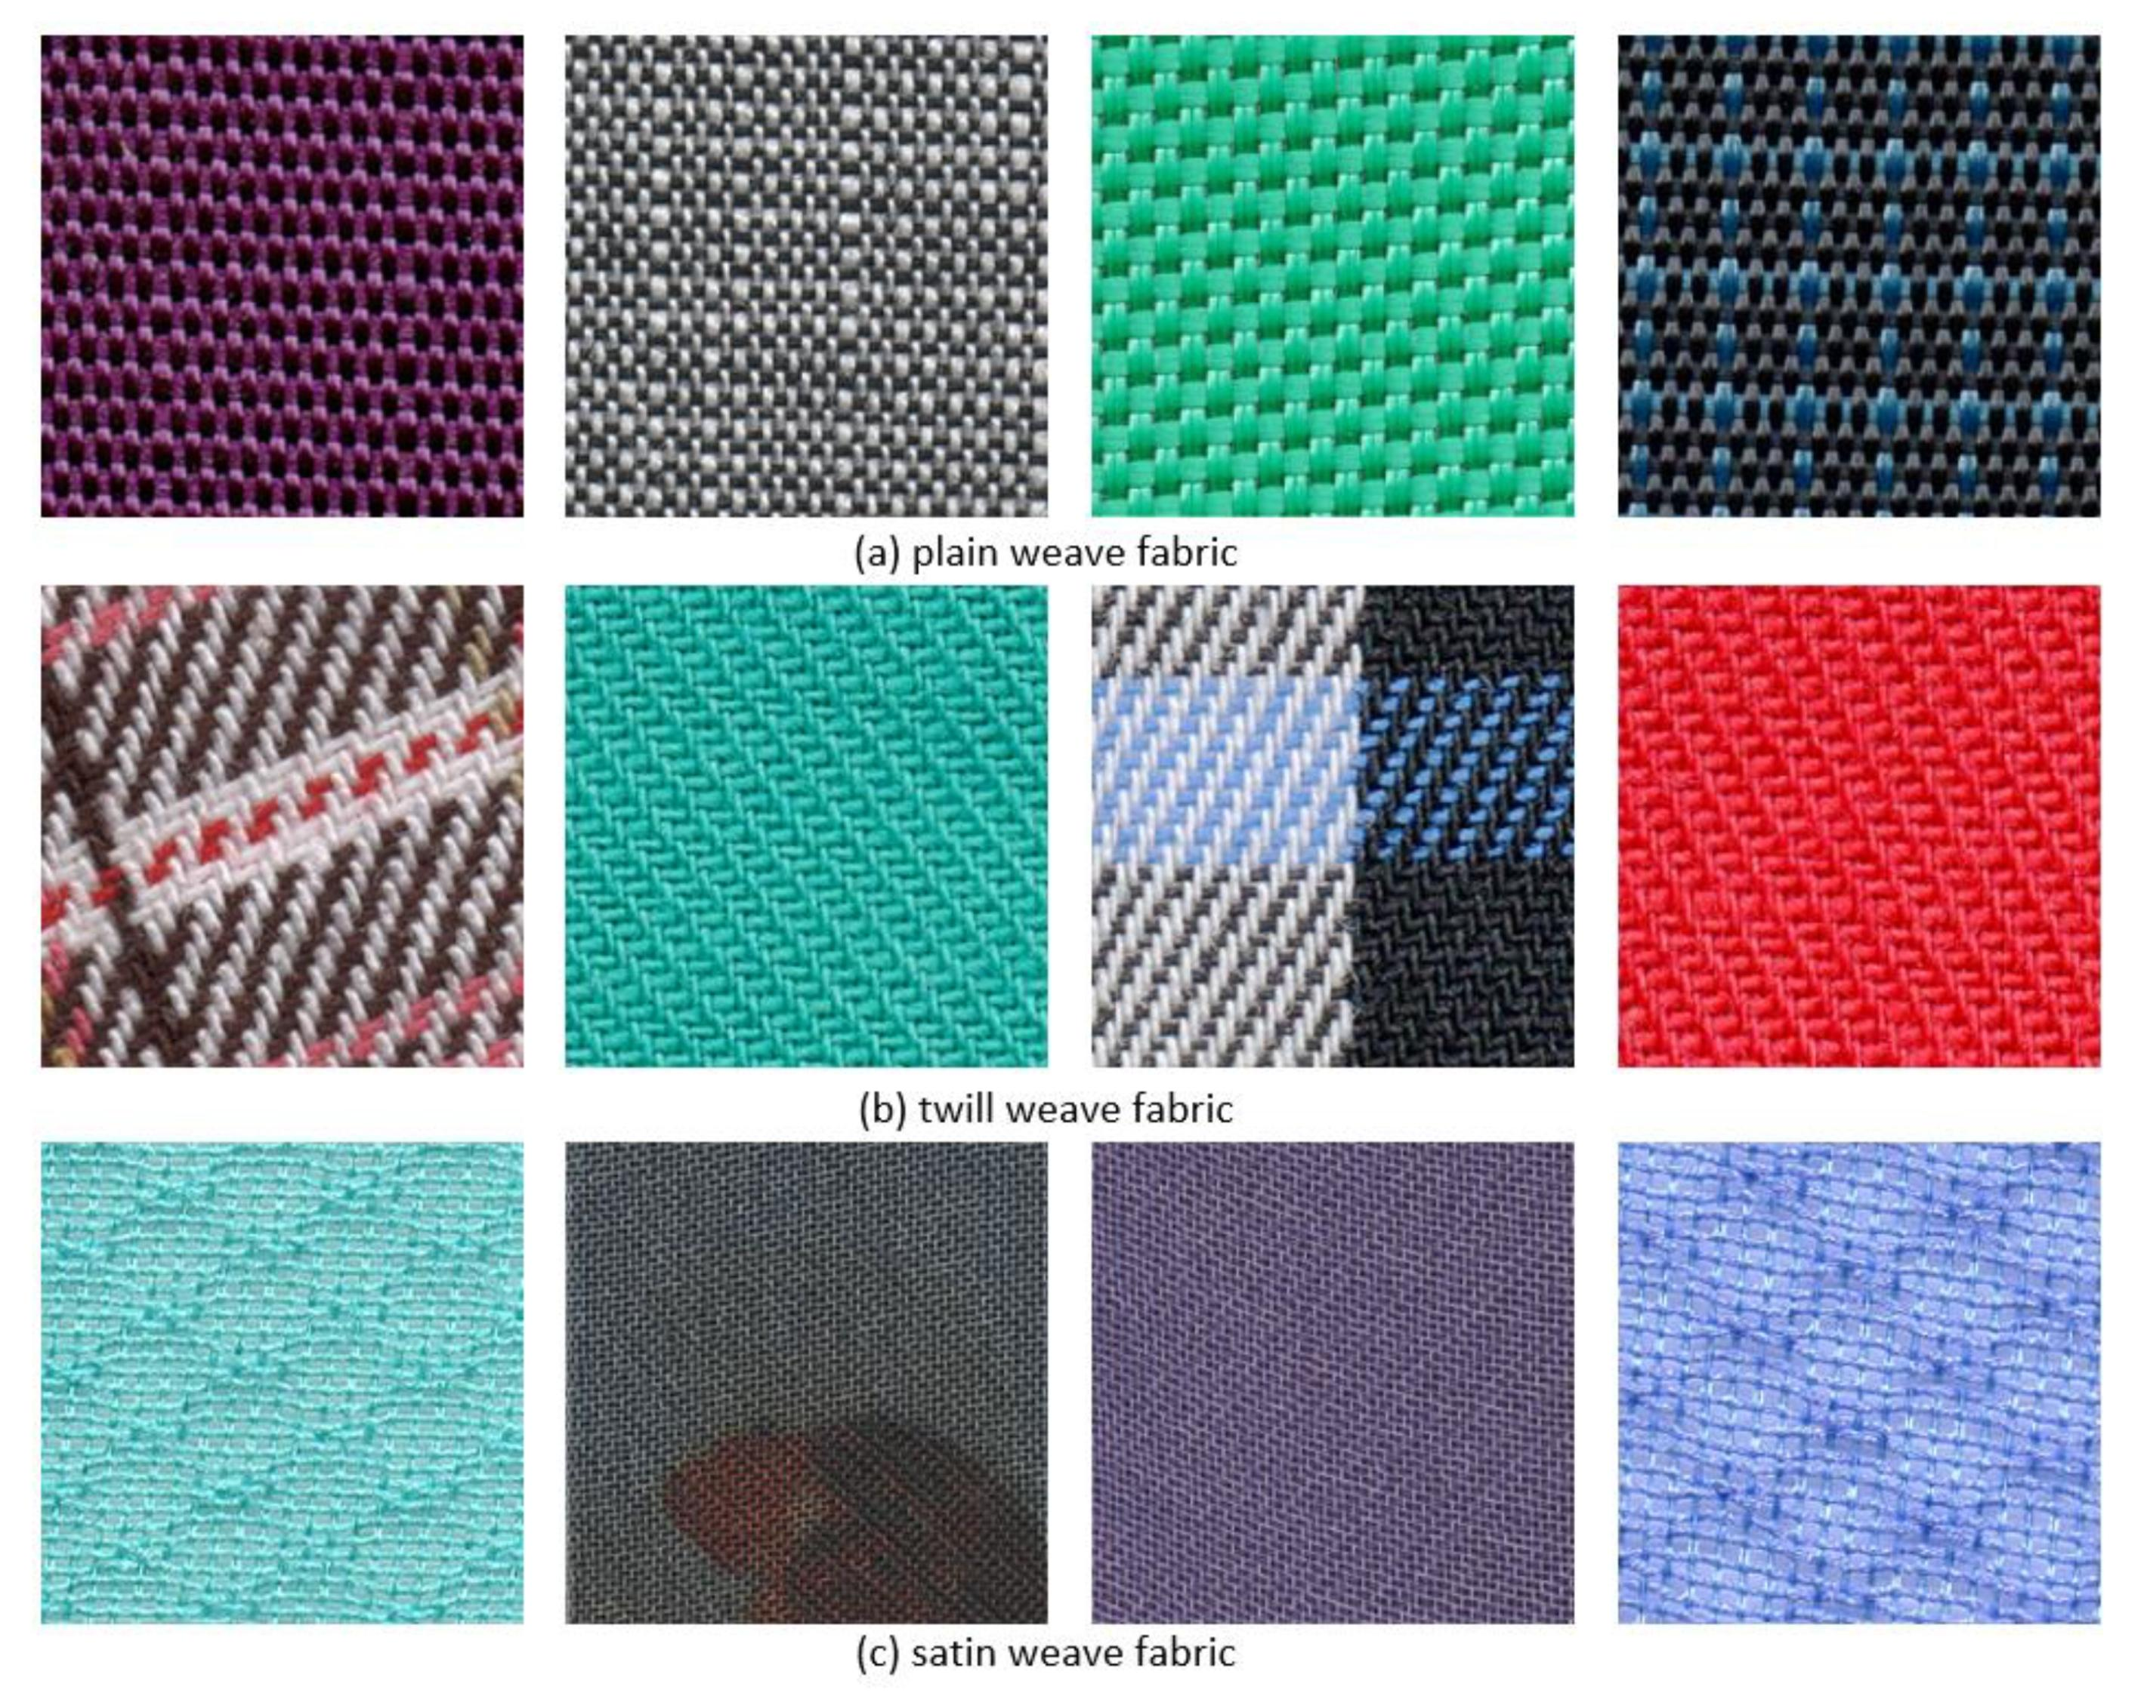

Grouped Ideas:

1. Model Development: CNNs, data augmentation, support for multiple pattern types

1. Data Management: Dataset creation and labeling

1. Deployment & Integration: Mobile app, production system integration, visual dashboard

## Step 3: Idea Prioritization

|  |  |  |  |
| --- | --- | --- | --- |
| Idea | Impact | Feasibility | Priority |
| CNN-based model for classification | High | High | High |
| Dataset of labeled fabric images | High | Medium | High |
| Real-time mobile app | Medium | Medium | Medium |
| Integration with production systems | High | Low | Medium |
| Data augmentation | Medium | High | High |
| Support for various fabric types | Medium | Medium | Medium |
| Visual dashboard | Medium | Medium | Medium |

Final Chosen Idea:  
Develop a deep learning model using CNNs trained on a labeled fabric pattern dataset, with support for deployment in a mobile application and integration into production environments to automate and enhance the fabric classification process.